initial_state = [0+1/sqrt(2),0+1j/sqrt(2)]
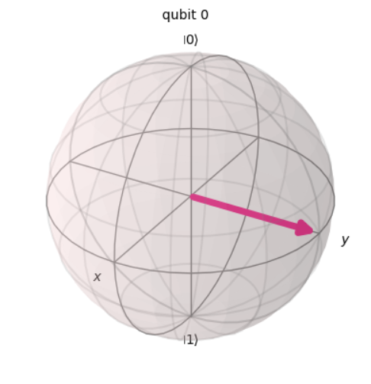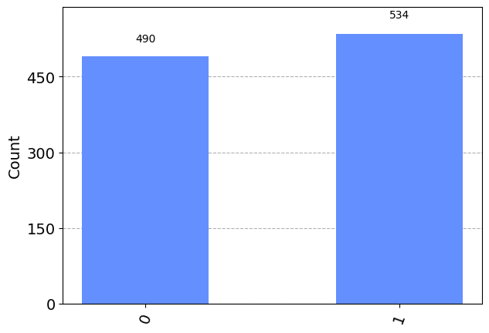

initial_state = [1/sqrt(2), (cos(pi/4) + 1j*sin(pi/4))/sqrt(2)]
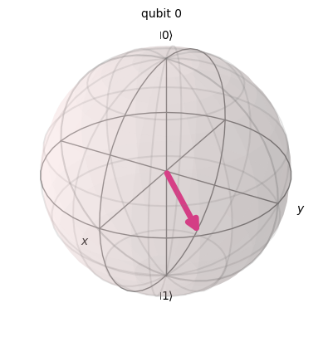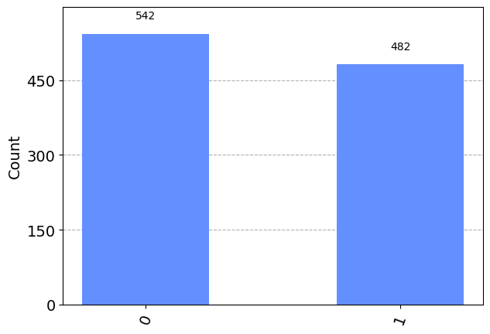

initial_state = [cos(pi/8), exp(1j*pi/2)*sin(pi/8)]
